CSS

Like a waterfall



It’s a style sheet language



But there are others

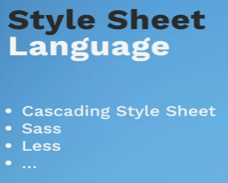

When the internet was new there was no CSS , only HTML

Keep the style in css and markup in HTML – for the most part

Separation of concerns

Can add in 3 ways

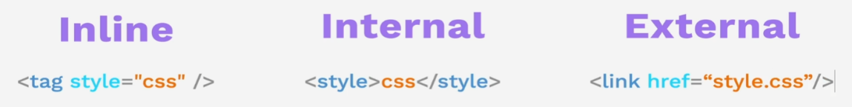

In line – right into the HTML use the style attribute in quotes separated by colon – ok for just a single element but don’t use for the whole site

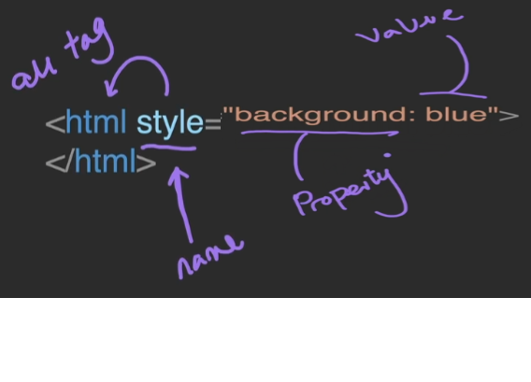

Can add a style element to a page and out the css there or use a link tag out to a file 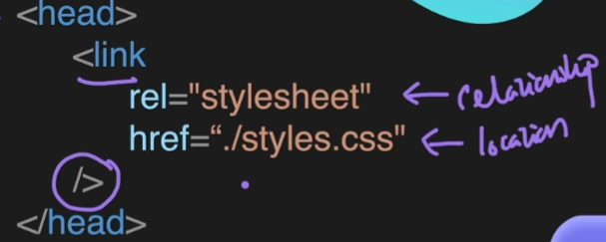

Don’t forget the curlys selector, property, value

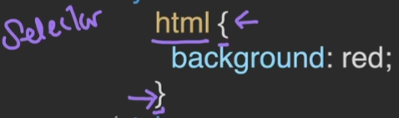

Selectors

Element selector

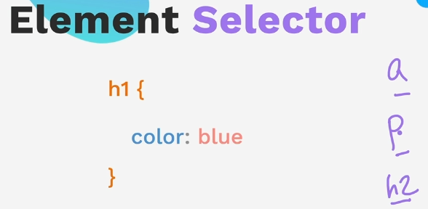

Class attribute selector –

Use .

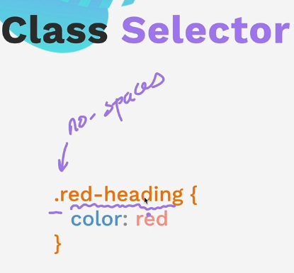

ID selector #

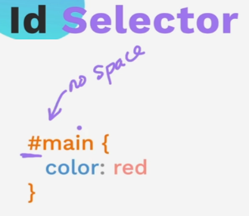

In general should just have one element with an ID on the page, but can have many of the same classes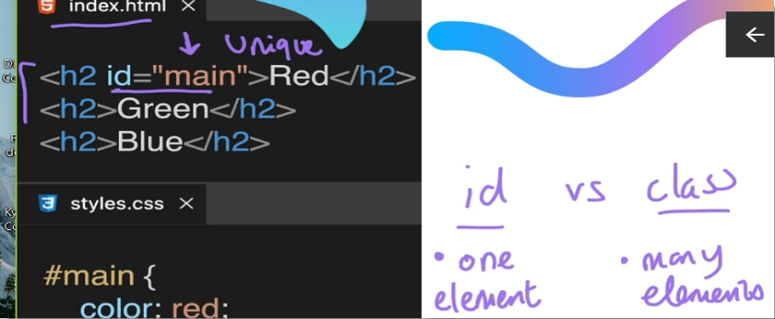

**The attribute selector**

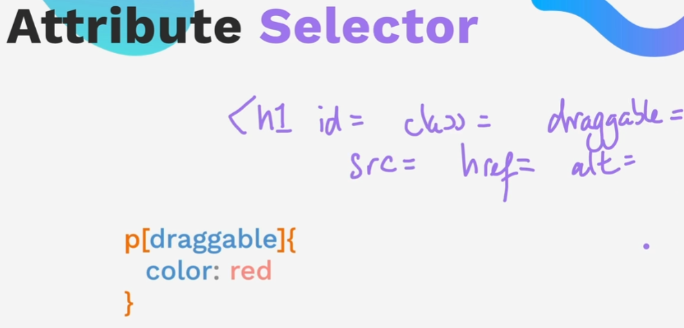

Syntax

Can also use the attribute value to select it

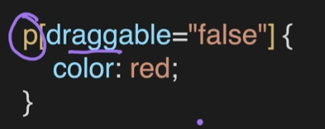

<https://developer.mozilla.org/en-US/docs/Web/CSS/Attribute_selectors>

[**Syntax**](https://developer.mozilla.org/en-US/docs/Web/CSS/Attribute_selectors#syntax)

[[attr]](https://developer.mozilla.org/en-US/docs/Web/CSS/Attribute_selectors#attr)

Represents elements with an attribute name of *attr*.

[[attr=value]](https://developer.mozilla.org/en-US/docs/Web/CSS/Attribute_selectors#attrvalue)

Represents elements with an attribute name of *attr* whose value is exactly *value*.

[[attr~=value]](https://developer.mozilla.org/en-US/docs/Web/CSS/Attribute_selectors#attrvalue_2)

Represents elements with an attribute name of *attr* whose value is a whitespace-separated list of words, one of which is exactly *value*.

[[attr|=value]](https://developer.mozilla.org/en-US/docs/Web/CSS/Attribute_selectors#attrvalue_3)

Represents elements with an attribute name of *attr* whose value can be exactly *value* or can begin with *value* immediately followed by a hyphen, - (U+002D). It is often used for language subcode matches.

[[attr^=value]](https://developer.mozilla.org/en-US/docs/Web/CSS/Attribute_selectors#attrvalue_4)

Represents elements with an attribute name of *attr* whose value is prefixed (preceded) by *value*.

[[attr$=value]](https://developer.mozilla.org/en-US/docs/Web/CSS/Attribute_selectors#attrvalue_5)

Represents elements with an attribute name of *attr* whose value is suffixed (followed) by *value*.

[[attr*=value]](https://developer.mozilla.org/en-US/docs/Web/CSS/Attribute_selectors#attrvalue_6)

Represents elements with an attribute name of *attr* whose value contains at least one occurrence of *value* within the string.

[[attr operator value i]](https://developer.mozilla.org/en-US/docs/Web/CSS/Attribute_selectors#attr_operator_value_i)

Adding an i (or I) before the closing bracket causes the value to be compared case-insensitively (for characters within the [ASCII](https://developer.mozilla.org/en-US/docs/Glossary/ASCII) range).

[[attr operator value s]](https://developer.mozilla.org/en-US/docs/Web/CSS/Attribute_selectors#attr_operator_value_s) Experimental

Adding an s (or S) before the closing bracket causes the value to be compared case-sensitively (for characters within the [ASCII](https://developer.mozilla.org/en-US/docs/Glossary/ASCII) range).

The universal selector *



36 Project color vocab website

Restart here

<https://www.udemy.com/course/the-complete-web-development-bootcamp/learn/lecture/37350332#overview>